

Student User Guide



For students in Grades 3-12

Table of Contents
Welcome and Login 3

Logging In 3
Menu Functions 4
Student Home Page with No Calendar Option 5
Student Home Page with Calendar Option ..................................... 6
My Courses 8
Begin and Continuing Work in a Course 9
Multimedia Presentations12
Vocabulary Activities 12
Spelling Bee 13
Vocabulocity 13
Farmer Frank 14
AllRight 14
Quiz Bowl 15
Translate 16
Reference 16
Question Types 17
Reviewing Your Work 21
Messages 23
Viewing a Message 23
Send a Message 24
My Settings 25
Logout 26

Please note: For technical support, please contact us at
academytechsupport@nflchurch.com

Welcome and Login
Welcome, the Login page is the single login location for NFC Academy. The system uses your login to know what access you need, displaying the correct Home screen for you.

Example: If you logon with a student’s username and password, you are given
access to that student’s school work.

Your Login page allows you to quickly view any school wide messages.

Logging In

- Enter your student username. This is the username the Academy has given to you along with your Academy site address and password.

- Press the Tab key, or click your mouse in the password textbox.

- Enter the password you received from the administrator.

Note: Usernames and passwords are case sensitive. Be sure to enter them
exactly as they were provided.

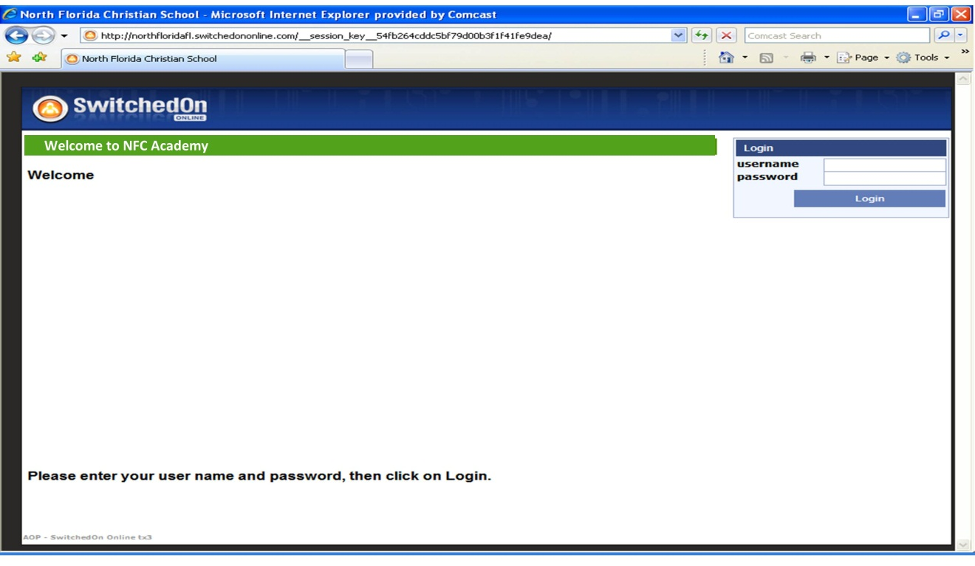

Note: You will have the ability to change your password. See page 25 for
directions.

Student Home Page and Tools
After successfully logging in, you are taken directly to the Student Home page.

The Student Home page looks different depending on how the student account is set up.

The school administrator will assign the school calendar on all students. See the discussion of Student Home page with the School Calendar option selected on page 6.

The Student Home page for students without the calendar option selected is discussed beginning on the next page, but should not be included in only rare options.

Student Menu Functions
The sidebar menu is the same regardless of the calendar setting you select. On this menu are six options to help you easily navigate around the NFC Academy environment.

Access student functions using the menu down the left side of every page in Student Mode:
Home:
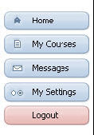
Returns the student to the Student Home page.

My Courses:
Takes students to their Course Schedule which displays teacher, date course work started, a progress bar, the date course work was completed, and the total score to date for the course.

Messages:
Students can send or reply to messages from teachers and administrators.
Note: Students cannot message other students.

My Settings:
Allows students to determine the best way to access multimedia content or change their password, if the administrator and teacher have permitted it.

Logout:
NFC Academy automatically logs you out after 60 idle minutes, but for security purposes, we encourage you to logout whenever you will be away from your desk.

Home - No Calendar Option – Remember
When your administrator sets up the student account, they are given the option of applying the School Calendar to the students course work. Depending on the choice the Administrator makes, your Student Home page has a slightly different look and functionality. NFC Academy will rarely use this option, so move to page 5 for the Calendar Option which is the standard for NFC Academy.

If School Calendar is not selected, you see a page that looks something like this:
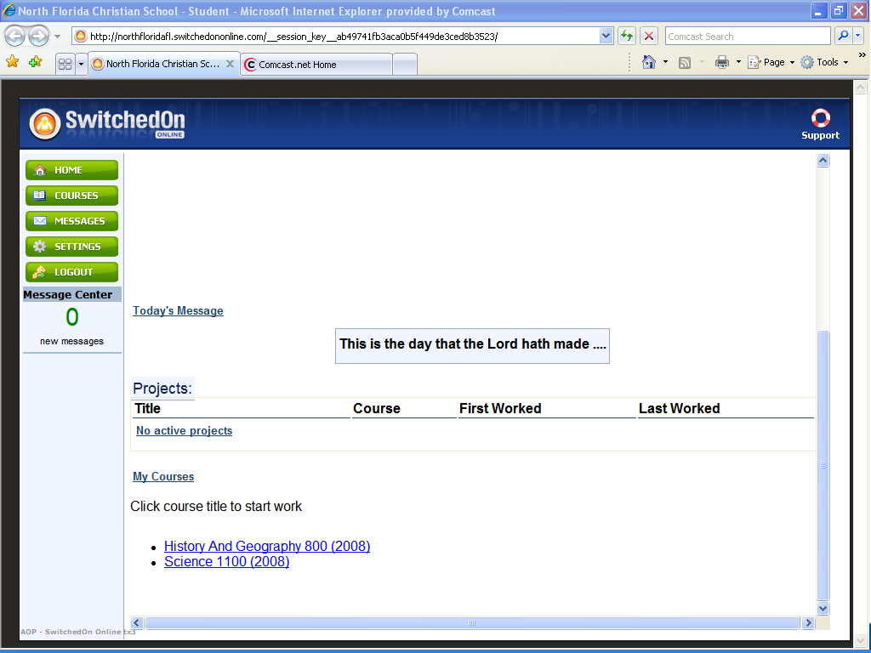
The first third of the page is dedicated to the Welcome message and the Message of the Day. Here, you can read messages the administrator chooses to display to the entire school.

The middle section of the screen contains the student My Courses section. Each course title appears as a link. Clicking the Title of a particular course takes you directly to the next assigned activity in that course.

Note: Accessing the course from the Student Home page is a shortcut. Students can also access their courses from the My Courses page. See page 8 of this document for more information on the My Courses page.

The bottom third of the page shows any new Messages you have received through the NFC Academy internal messaging system.

Reading a New Message
To read a message, simply click the message title. Once a New Message has been read, it automatically moves to Past Messages tab. Please see the Messaging System discussion beginning on page 23.

Next let’s look at the Home page for students who have been assigned the School Calendar option.
Home - Calendar Option – All NFC Academy students will have this option unless specifically notified differently.

There are a few differences in the Student Home page if the School Calendar option was selected by the school Administrator.

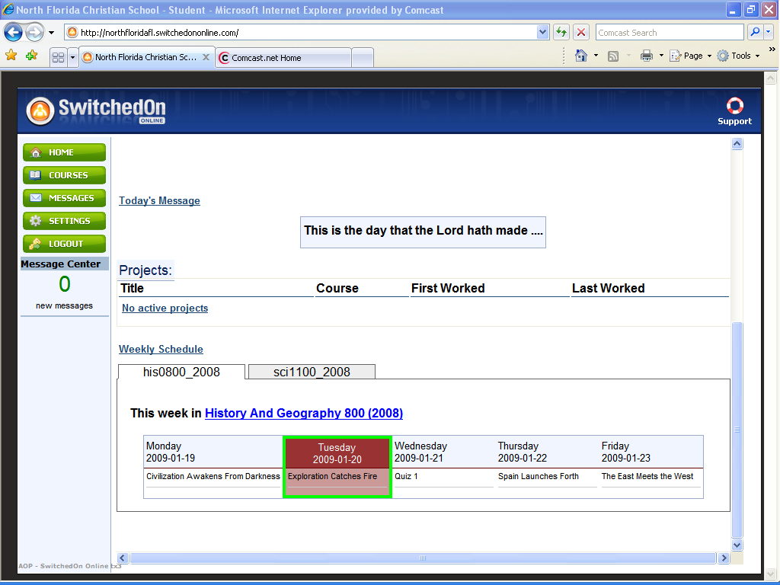

The top half of the page is the same whether the School Calendar option is used or not. You still see the Welcome message and the Message of the Day displayed.

The bottom half of the page shows your Weekly Schedule by course. The Weekly Schedule heading displays each course assigned to you on a tabbed page. Click a tab to view the week’s assignments in that course. You may click the Course name link right above the weekly schedule, or click My Courses in the sidebar menu to begin working on assignments.

The Weekly Lesson Plan maps out what you need to accomplish each day of the week in order to stay on pace.

The lesson plan in no way limits your productivity. If you finish all the assignments for a given day, you can continue working ahead. On Sunday night, the system assesses remaining assignments yet to be completed, and evenly disperses your remaining work across the days left in the school calendar. Your teacher’s weekly assignments provided in the course syllabi or information sheet may not always align with the computer’s lesson plans because of doing more/less work in a week.

Home - Calendar Option

Each NFC Academy student will have a customized School Calendar End Date based upon their starting date.

- The administrator will set a Custom End Date for the course, on the Assign Courses page. The customized calendar is based upon your start date and the expected end date for the course. Course lesson plans are generally done for an entire school year unless the course is a .5 year course. The lesson plan generator then uses the customized course date to create the Lesson Plan for that specific course using your specific start date and end dates.

My Courses
When you navigate to the My Courses page, you see all your courses listed inside the table at the top of the page. At a glance, you are able to see the Title of the course and grade level, the name of the Teacher assigned to the course, the Date Started, a quick view course Progress bar, the Date Completed (for the entire course) and your Total Score for the course.

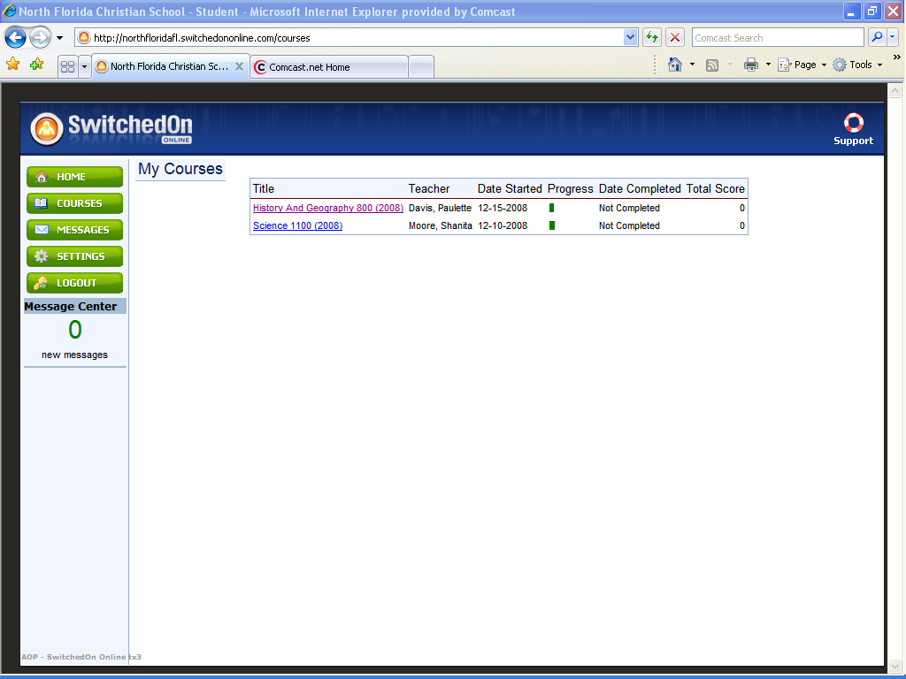
My Courses
Begin and Continuing Work in a Course:

- Click the course Title to navigate to the Chapter View.

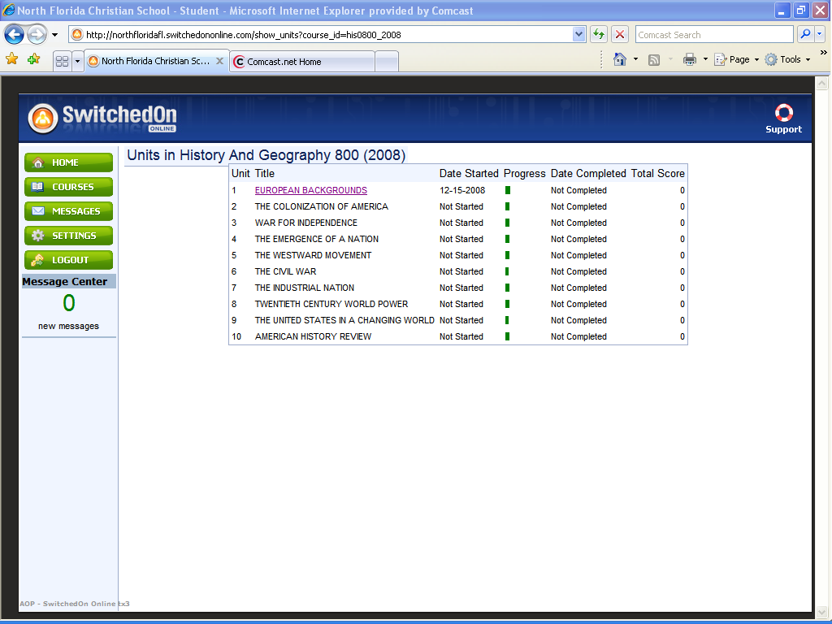

On the Chapter View page, as seen on the next page, all the chapters, or units, in the course are displayed inside a table. Each chapter listing displays the Title of the chapter, the Date Started, a quick view Progress bar, the Date Completed, and the Total Score for the chapter.

My Courses

When you click a Unit Title and open the Activities View, as described on the following page, you may see up to five different assignment types:
- Lesson – these are the primary assignment types you are likely to see. They include presentation material and questions/problems about the material to be answered.

- Quiz – after every few lessons you see a quiz. These are a series of questions designed to test what you have learned in the unit to this point.

- Project –various activities and reports to help support and enhance your learning. They may use several different applications, such as, Microsoft® Word, Excel, PowerPoint, or others. If you are unsure what to use, ask your teacher.

- Test – like quizzes, tests are a series of questions and problems to help assess what you have learned in this unit. Be sure to review before taking a test!

- Reference – This lesson contains a listing of all of the vocabulary words in the unit, and the internet links referenced in the unit. You can also read a brief paragraph about the author(s) of this course.

2. Click the Title of a chapter to navigate to the Activities View.

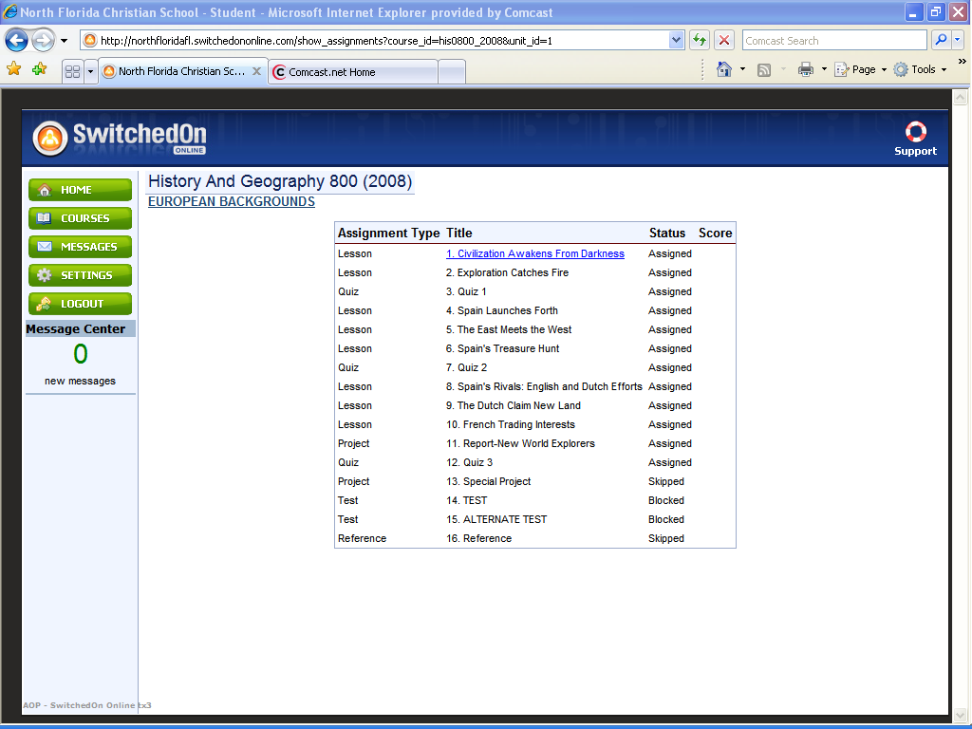
The Activities View lists all the educational activities in that chapter in table format. Each listing also displays the Assignment Type, the Title of the assignment, the Status and the Score.
My Courses

3. To open a lesson you just click the activity Title.

In the Status column, you may encounter four different status selections.
- Assigned: You are required to complete this assignment.
  - Skipped: The computer does not deliver this activity to you (you cannot skip work in the course, but if you transfer into the Academy mid-year you may be given transfer credit for work done in a particular course allowing you to skip certain units based upon your work at your previous school)
  - Blocked: You cannot take this assignment or continue working without teacher permission.
  - Completed: You received this assignment and have completed it with a score at or above the pass threshold, if in use.

Note: You are not able to view any activity, other than the title, until you reach a
lesson, project, quiz or test in the order assigned to you. This means you must complete the work in one activity with a score at, or above, the pass threshold before another activity in the subject is available to you.

WARNING: If you are taking a quiz or test, you should not navigate away. Typically if you do you can expect to return to the quiz/test to complete it, however, it is possible your browser can close the quiz/test if you navigate away and score all unanswered questions as a zero. If this occurs you may contact your teacher for reauthorization to retake the quiz or test. You should keep in mind this process would not be a normal expectation and should not occur and if it does should not be repeated.
My Course/Working in NFC Academy
Multimedia Presentations

NFC Academy contains over 25,000 multimedia presentations, such as videos, games, labs, newsreels, and famous speeches, just to name a few. The following is a brief guide to help you understand the items you encounter.

Playing Multimedia Presentations

Anytime you see the movie projector, speaker icon, or the words “click here” you can click the link to play the video or audio clip. When you position your cursor over a picture and the cursor changes to look like a hand, you can click the picture for a presentation also.

Vocabulary Activities

NFC Academy believes that expanding a student’s vocabulary is essential for success in any discipline. To that end, there are several games in each lesson that offer repetition exercises for that lesson’s vocabulary list.

Near the beginning of each lesson, all of the vocabulary words for that lesson are listed. They display as underlined blue links. Your students can hear the correct pronunciation of the word by clicking the highlighted word.

There are several activities, such as Spelling Bee, Vocabulocity, Farmer Frank, and All Right, which help to reinforce the vocabulary words in most of the lessons.

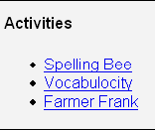
My Course/Working in NFC Academy

Spelling Bee

Spelling Bee quizzes are not just on spelling, but also on keyboarding. You pick your bee representative and then a robot gives you a word from the list. You must spell the word correctly. If you misspell the word the robot gives you the correct spelling. You then have the opportunity to correctly spell the word before the activity is completed.

Vocabulocity

Vocabulocity takes place in the far reaches of outer space. Your ship is trying to make it back to base at the space station “Vocabulocity”. You are given a definition and three choices. If you pick the right option, you can continue, if you pick the wrong choice you are brought back to your Vocabulary list for further study.

My Course/Working in NFC Academy

Farmer Frank

Farmer Frank is our version of Hangman. You are given a definition from the activity vocabulary list. A clue is given, and a blank space is provided for each letter in the mystery word. At the bottom of the screen you click a letter from the alphabet. If that letter appears in the mystery word, the letter appears in the appropriate blank(s) and Farmer Frank begins to build his spaceship. You may also use the keyboard to select a letter. Once all the letters are uncovered you may qualify for a time bonus.

All Right

All Right is our version of Jeopardy. You click a skateboard and are presented a question about a point covered in the lesson. Options are presented similar to a multiple choice question. You click an answer. If it is correct, the question mark becomes a “thumbs up”. When all questions in a row or column are correctly answered, that row of skateboards flips over, ready to ride. If the answer is wrong, the correct answer flashes and the skateboard breaks in half. When you successfully complete two rows or columns, you earn the chance to repair one broken skateboard by successfully answering the question.

My Course/Working in NFC Academy

Quiz Bowl

Quiz Bowl is a review activity in grades 3 through 6. You find it at the end of each unit in Math; Science; Language Arts; and History and Geography. Just open the Review lesson at the end of the unit to see the Quiz Bowl screen displayed. Click Begin. On the main game screen (see example below). Click Help for instructions on how to play Quiz Bowl, or Play Game to get started with Quiz Bowl. The About button simply gives you an overview of the game and shows you the software needed to play the game. Click the Back button to return to the main game screen.

My Course/Working in NFC Academy

Additionally, there are two dynamic reference tools available to you while in your lessons, you should be aware of as well. Look for the Tools section below your Logout button in the left-hand column.

Translate

The translate feature allows you to read words and phrases from your assignment into several different languages including French, German, Spanish, Korean, and more.

- Highlight the word or phrase you want to see translated.

- On the left side of the screen, select the language from the pull down menu.

- Click Translate From or Translate To.

Note: The translate feature provides a word for word translation of the highlighted passages. You should not rely on the translate feature for things like verb conjugation and gender agreement.

Note: The translate function works best when small passages are highlighted.

Reference:

Student mode provides a reference tool so that you can look up more information on any word in your assignments. Simply highlight the term and click Reference on the left side of the screen. A new window opens with the encyclopedia entry for the highlighted word. If a new window does not open, there is no information available.

My Course/Working in NFC Academy

Question Types

When you begin working in NFC Academy the first thing you may encounter is any note(s) the teacher has added to the lesson through the Add Note field. If you can’t find these, ask your teacher to point them out to you so that you don’t miss any important information. For students in grades 9-12 your teacher will post important information on their Moodle site for your access to material to download.

After you play the games, engage with the multimedia and read the text, you are given a series of questions to check your understanding of the presented material. There are several different question types.

WARNING: Always click or press the tab key after you enter an answer, watch the far
right side of the question box for the “sending” message. You should also notice that the question box flashes when NFC Academy saves your answer. If you do not see this happen, your answer may NOT have been saved and will be marked as incorrect.

The following types of question are scored automatically by NFC Academy.

Multiple Choice
Multiple choice questions offer three to five choices per question. You just need to click in the bubble next to your answer choice. Make sure you have read the question or instructions carefully.

Multiple Select
Multiple select questions offer a number of choices per question. You click in the box next to each answer you believe to be correct. The question will often tell you how many correct choices there are.
My Course/Working in NFC Academy

True and False

True and False questions are a way of verifying that you have grasped the factual concepts present in the material. You just need to click the bubble next to your choice.

Fill in the Blank / Unordered

You are given a sentence with one or more words missing. You must select the correct word or words and type them into the field provided. All of the answers can be found in the text. Make sure you pay attention to capitalization, punctuation and spacing in your answers.

Matching
In matching questions, you are given two columns of related information; for example, words in one column and definitions in the other. One column has empty boxes in front of each item, the other column has numbers. You place the number of an item in the box next to the corresponding item in the second column.
My Course/Working in NFC Academy

Text Multiple Choice

In all text multiple choice questions, the answer box is highlighted in blue. Each time you click your mouse in the blue box, the pre-set answer changes. You should click until the answer you believe is correct shows up in the answer field.

Click and Place (previously known as Drag and Drop)

This type of question is used to label graphics or set up math equations. You click the item in the menu below the main graphic to select it; then position the mouse in the location where the item is to be placed, and click again. You may click multiple times to place the item. If you put one item on top of another, the second item replaces the first. You can also click Start Over to clear all items already placed. To clear only one item, click Erase, and then click the item to delete.

My Course/Working in NFC Academy

Preloaded Questions

In preloaded problems, you generally see an answer (usually a word, phrase, sentence, or paragraph) already in a box. If you think the displayed answer is incorrect as is, type any change(s) in the box, making sure the answer reads exactly the way you want before continuing. If you think the answer is correct, delete the entire entry and re-type the correct answer into the box.

Sometimes, preloaded problems appear on top of special backgrounds or other graphics ---you still approach them in exactly the same way.

Teacher Graded Questions

The following question types are not scored by NFC Academy. They must be scored manually by your teacher.

Note: Keep in mind, the computer scores these questions as a zero until the teacher
enters a grade.

Short Answer

You are provided an answer box, and the expectation is that you answer the question in sentence format. Your NFC Academy teacher (Home School Advantage Edition) will need to grade this section. Contact your teacher for any questions about grading Short Answer questions.

Essays

You are expected to expound upon a theme in paragraph or essay format. You should demonstrate mastery of the concept by stating a theme and appropriate supporting reasons.

Warning: Be sure you click Save after you finish entering your answer.

Special Projects

We understand that teachers have lessons that are time-tested classroom favorites. The Special Project slots are a blank field that they can use to incorporate their own lessons. In Teacher Mode, they can use the Add Note command to enter their instructions. Don’t forget to Upload your project when you are finished!
Student Mode/My Course/Review Work

In the NFC Academy environment, you must work lessons and quizzes in a set order. For instance you can’t decide you are tired of working on chapter 1 and go work on chapter 9 instead.

When you begin your work, you are taken to the first assigned activity. Once that assignment is completed, the Assignment Title and the Chapter that contains it are highlighted in blue.

When you are approaching test time, you may want to take time for review. When you are ready to review you should:

- Click My Courses from the sidebar menu.

- Next click the Course that you want to review.

- From the Chapter View, you can enter any highlighted chapter by clicking the Chapter Title.

- From the Activity View, you click any activity that displays “Completed” in the Status column.
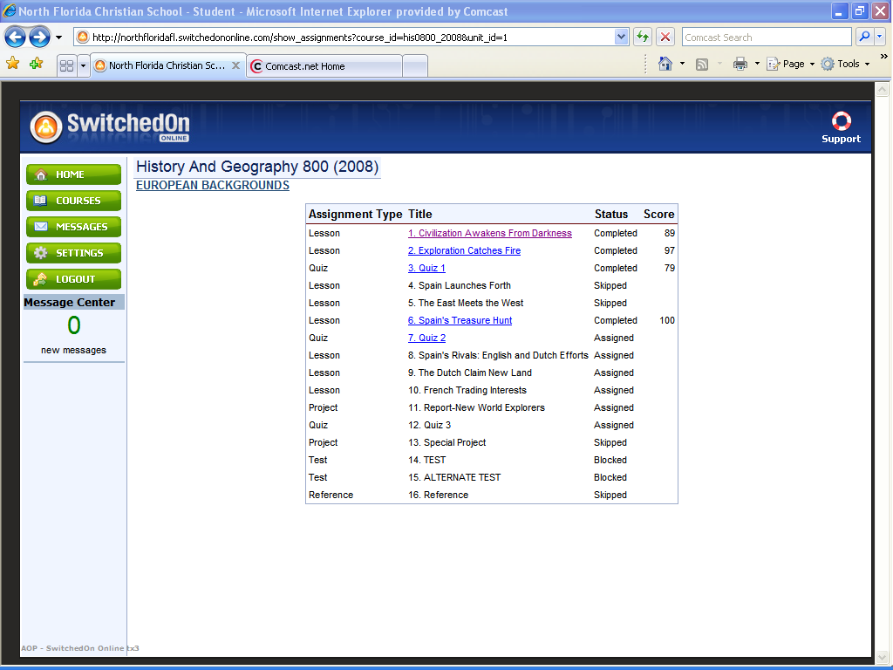

This takes you to the activity page where you can select any lesson to read through again, scroll through and see what questions you answered correctly and which questions you missed when you first did a lesson. You can also take another look at any completed quizzes. Keep in mind, quizzes are cumulative, so it is a good idea to review your completed work frequently to make sure you are clear on all of the key concepts and skills covered in each lesson, especially before you take another quiz or the unit test.

Student Mode/My Course/Review Work
Note: You cannot review an activity until you have completed it with a score at,
or above, the pass threshold. This also means a new chapter will not open for you, until all assigned work in the previous chapter is completed satisfactorily.

Show Answer Key

Once an assignment is complete, meaning it has been graded, you are able to review the entire assignment.

- Locate the question whose answer key you want to see.

- Click Answer Key next to the question type to display the correct answer.

- Click Hide Key when you are finished.

Student Mode/Messages

You can use the Messages option to send messages to the any of your teachers.

Note: You cannot message other students. However, you will be able to collaborate and discuss with other students using the Discussion Board/Teacher Postings on Moodle (Grades 9-12).

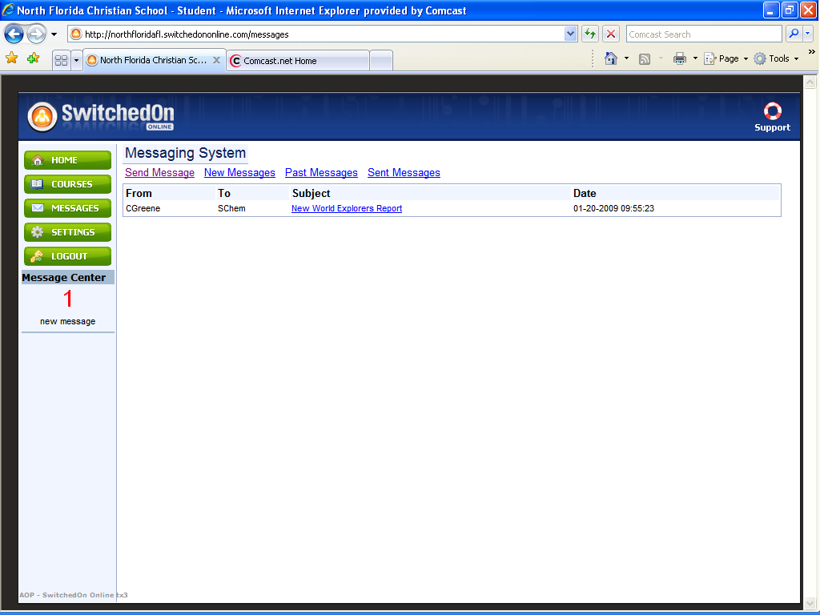

The Messaging Home page automatically displays a listing of your new messages when opened. Each new message is displayed with the sender name, the subject, and the date received.

Viewing Messages

To see a new message, click the highlighted Subject header. To view the next new message click New Messages. Messages you have already read automatically become a Past Message. To take another look at a message, just click Past Messages above the list of new messages.

Sending a Message

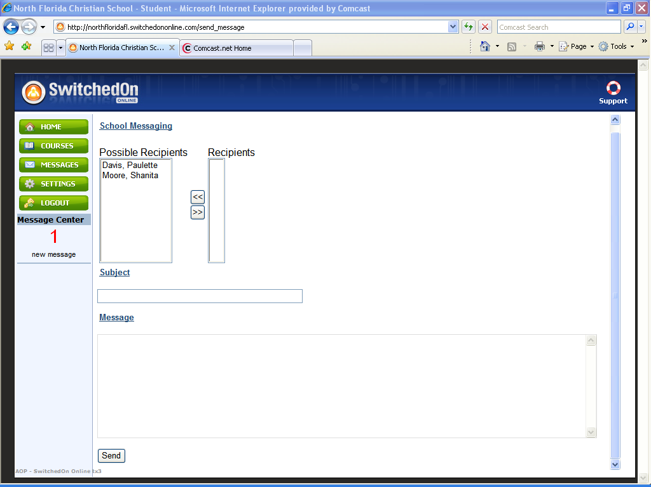
To send a message to a teacher, click Send Messages above your inbox on the Messages Home page.

Choosing Recipients
Select the name of the recipient from the Possible Recipients list on the left. Click the button with the set of arrows pointing to the right to add the selected person to the Recipients list.

Hint: Hold the Control (Ctrl) key down while clicking to select multiple
recipients. To select a group of adjacent names, click a name, hold the Shift key down, and then click the last name of the group you want to select. This feature works when both choosing and removing recipients.

Removing a Name from the Recipient List

Click the name of the recipient you wish to remove. Click the button with the set of arrows pointing to the left to remove the select name(s) from the list.

Completing the Message

- Enter a Subject header. This is then displayed for the recipient.

- Enter the content of your Message.

- Click Send to send your message to all the people on the recipient list.

When people receive your message they can respond by simply clicking Reply.
My Settings

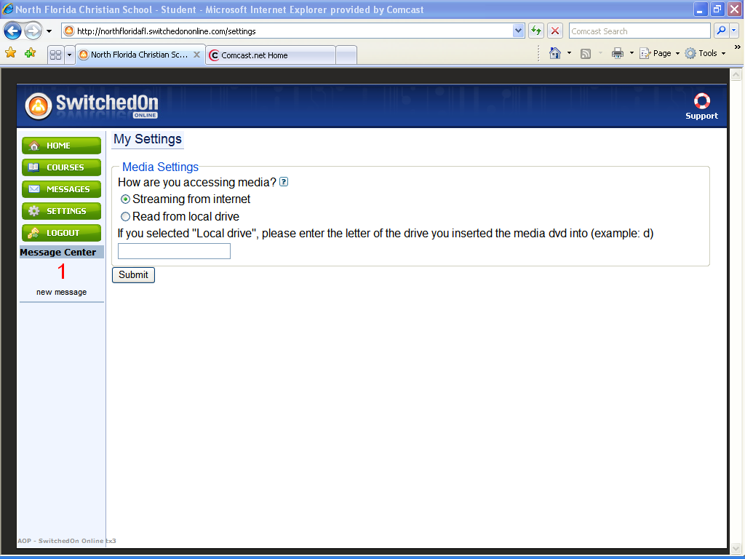

My Settings includes up to two possible options, Media Settings and Change Password, depending on how your school administrator set your permissions.

Media Settings

If you access the media through the internet, you do not have to do anything. The default setting tells the application to get the media from the internet. If you are using a DVD to access the multimedia, you must tell the application where to find your multimedia files.
To use a DVD for Multimedia access:

1. Click My Settings.

2. Choose Read From Local Drive.

3. Enter the letter of the drive reads your DVDs followed by the colon, for example: D:

Note: Your drive must read double-layered DVDs.

Note: Choose Streaming from Internet when you have a faster connection!

Change Password

If your administrator and teacher have allowed, you can use this page to change your password. Simply type in the new password you want to use in the Enter new password textbox, and again in the Re-enter new password textbox, click Submit and you are done.

Remember, if you don’t click Submit, the changes are not saved!
Logout

When you are finished working in the NFC Academy environment, be sure to log out. NFC Academy automatically logs out users after 60 minutes of inactivity.

Note: For security, it is recommended that users logout whenever they are
away from their desk.

When you logout you are returned to the Login page.

